**CoogSoft 2nd Gameplay Test Document**

**Ninja Tower - Ghost Produce**

**Fun Factor:**

**Glitches/Issues:**

* 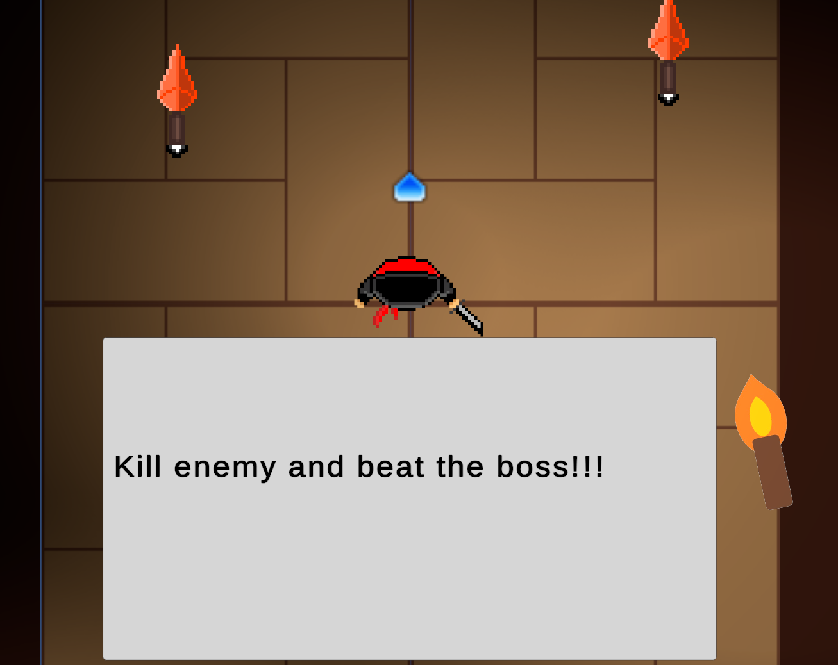 ”Kill enemies and beat the boss”
* 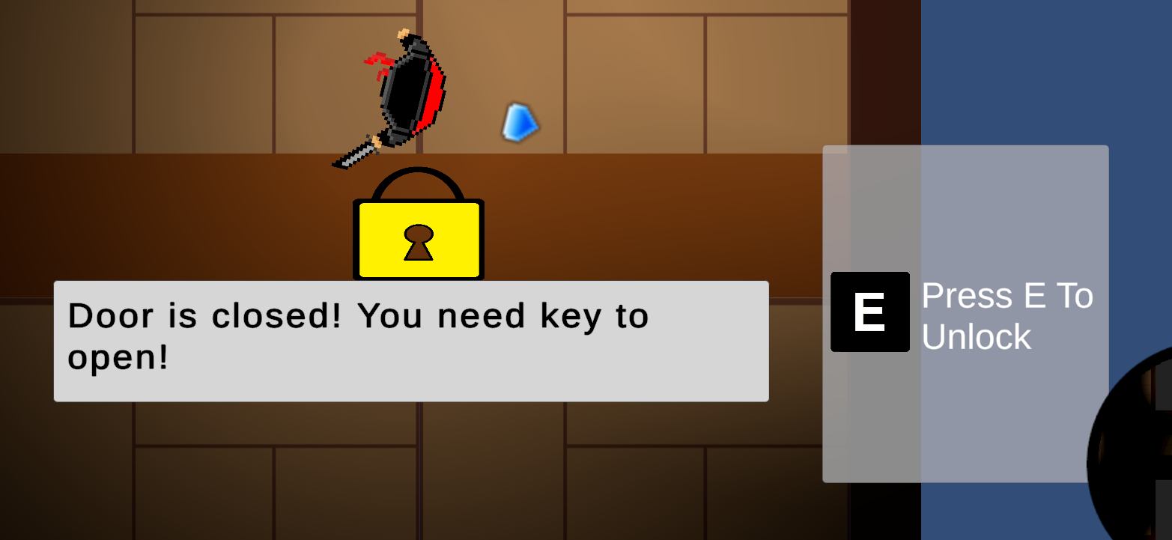 UI canvas height to big
* When hitting the melee enemies twice, they get knocked back and it looks like they have a little health left, but they die like a second after the last strike (its like theyre delayed)

**Suggestions:**